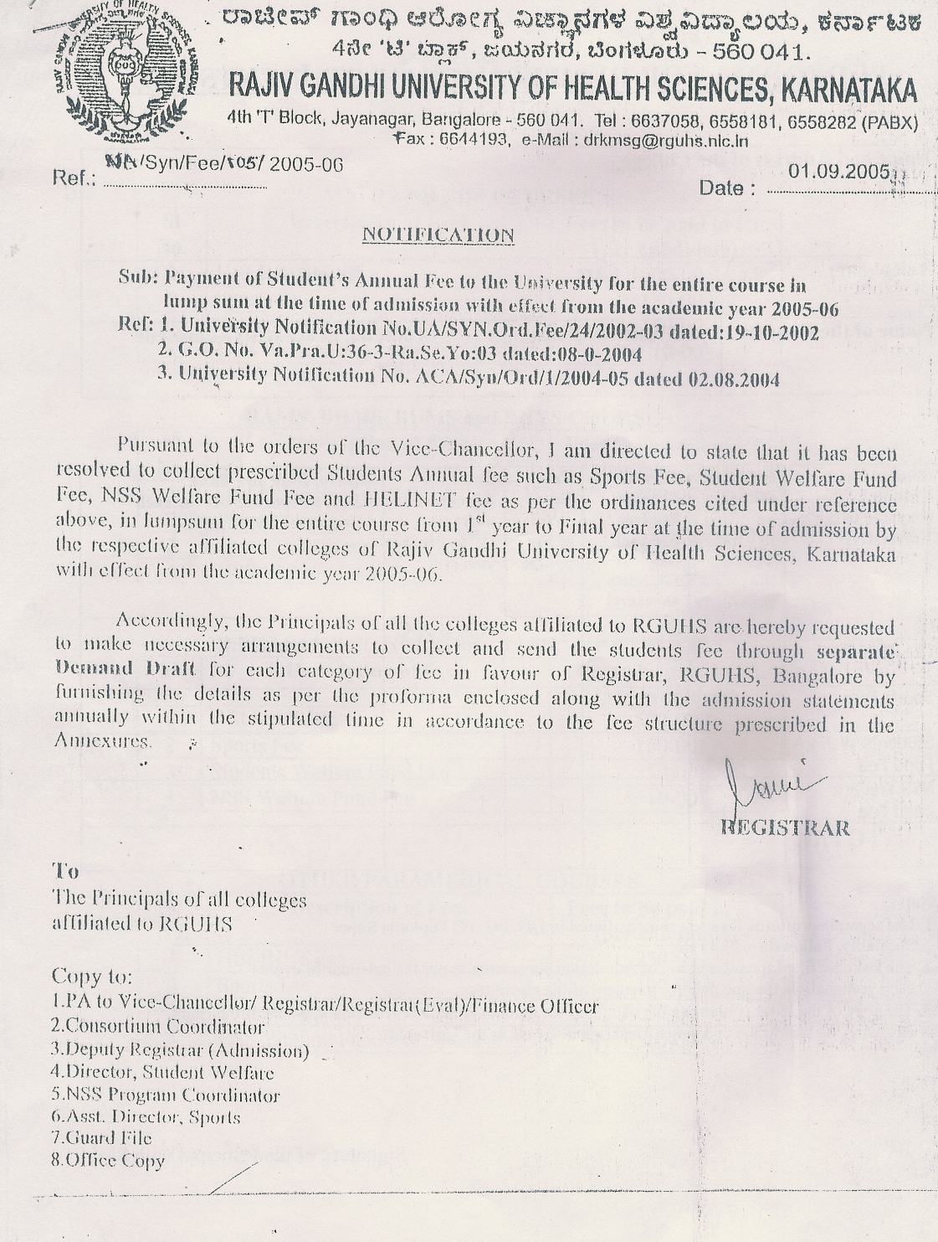

PROFORMA FOR REMITTANCE OF STUDENTS FEE

Name and Address of the college
Telephone: Fax: Email:
Name of the Course | Academic Year: |  | Total no of students admitted:

Students Fee category (payable to the University) | No. of students admitted to first year of the course | Prescribed Fee student per year(see respective annexure) | Total No of year of the course | Total amount for all years(!sty to final year) | DD No. Date and Bank(obtain separate DD for each category of fee)
Students Fee category (payable to the University) | A | B | C | AXBXC
HELINET Fee
Sports Fee
Students Welfare Fund Fee
NSS Welfare
Fund Fee
Total
Note:
Use separate proforma for each course offered in UG,PG,PG Diploma Super Specialty ,Fellowship,Ph.D ect
The last date fixed for submission of statements as per the calendar of events each year shall be the due for payment of the above fees.
The copy of the letter containing the details of the amount paid, D D No. &date, Name of the Bank, ect, shall be sent t the concerned Department heads in the University.
Signature of the Principle with Seal

ANNEXURE-I

FEES DETAILS

MBBS AND BDS COURSES
Sl.No. | Description of Fees | Fees to be paid in Rs. (Per candidate)
1 | HELINET Fee | 1000-00
2 | Sports Fee | 150-00
3 | Students Welfare Fund Fee | 150-00
4 | NSS Welfare Fund Fee | 10-00

BAMS, BHMS, BUMS and BNYS COURSES
Sl.No. | Description of Fees | Fees to be paid in Rs. (Per candidate)
1 | HELINET Fee | 300-00
2 | Sports Fee | 50-00
3 | Students Welfare Fund Fee | 50-00
4 | NSS Welfare Fund Fee | 10-00

B.PHARM, B.SC NURSING (BASIC & P.C), B.P.T
Sl.No. | Description of Fees | Fees to be paid in Rs. (Per candidate)
1 | HELINET Fee | 500-00
2 | Sports Fee | 100-00
3 | Students Welfare Fund Fee | 50-00
4 | NSS Welfare Fund Fee | 10-00

OTHER PARAMEDICAL COURSES

Sl.No. | Description of Fees | Fees to be paid in Rs. (Per candidate)
1 | HELINET Fee | 250-00
2 | Sports Fee | 100-00
3 | Students Welfare Fund Fee | 50-00
4 | NSS Welfare Fund Fee | 10-00

ANNEXURE-II

FEES DETAILS

PG MEDICAL (MD, MS and PG DIPLOMA) AND
PG DENTAL COURSES (MDS)
Sl.No. | Description of Fees | Fees to be paid in Rs. (Per candidate)
1 | HELINET Fee | 2000-00
2 | Sports Fee | 150-00
3 | Students Welfare Fund Fee | 150-00
4 | NSS Welfare Fund Fee | 10-00

PG AYURVEDA AND PG HOMEOPATHY COURSES
Sl.No. | Description of Fees | Fees to be paid in Rs. (Per candidate)
1 | HELINET Fee | 600-00
2 | Sports Fee | 50-00
3 | Students Welfare Fund Fee | 50-00
4 | NSS Welfare Fund Fee | 10-00

M.PHARM, M.SC NURSING AND M.P.T
Sl.No. | Description of Fees | Fees to be paid in Rs. (Per candidate)
1 | HELINET Fee | 1000-00
2 | Sports Fee | 150-00
3 | Students Welfare Fund Fee | 150-00
4 | NSS Welfare Fund Fee | 10-00

SUPER SPECIALITIES, FELLOWSHIP PROGRAMMES AND Ph.D
Sl.No. | Description of Fees | Fees to be paid in Rs. (Per candidate)
1 | HELINET Fee | 2000-00
2 | Sports Fee | 150-00
3 | Students Welfare Fund Fee | 150-00
4 | NSS Welfare Fund Fee | 10-00

